**Use of the GeoMx “Rare Cell Contouring” ROI Selection Script**

**Intended use**

The Rare Cell Contouring ROI selection script was designed for any GeoMx assay/experiment to enable contouring on a cell-type specific segment.

This ImageJ script does the following:

1. Creates a cell-type specific mask with a given ROI based on a fluorescent marker of interest
   1. the user can select the fluorescent channel and tune their mask thresholding
2. Creates a geometric ring contour mask around the created cell-type mask
   1. the user can define the ring distance
3. Creates a third mask that contains the remaining area in the given ROI
4. The script will output 3 masks that can be uploaded into the GeoMx Control Center and 1 visual reference image for user reference displaying the masks together overlaid on the ROI.

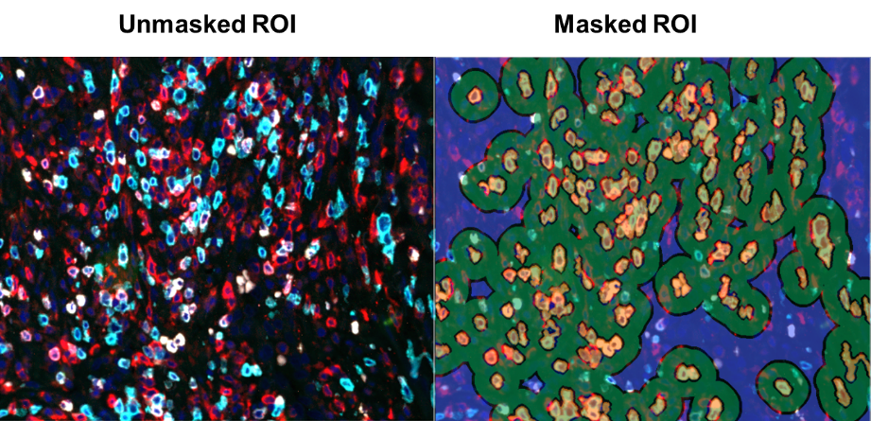

**Instructions for Use**

1. To perform these steps, you must be working on a computer that has ImageJ installed and is networked to the GeoMx® DSP. Alternatively, if not networked, you can move the necessary files (e.g. masks) via USB to upload directly on the GeoMx.
2. From the external computer, open ImageJ. Then, open Chrome and access your GeoMx**®** workspace remotely:
   1. Browse to [https://geomx-####](https://geomx-) where #### is the GeoMx**®** instrument number; find this under Administration tab >> Network >> Machine Name.
3. In the GeoMx**®** Scan Workspace, create or select a geometric ROI. The segmentation masks you create in subsequent steps will be confined within this ROI.
4. On the left panel in the workspace is where the ROIs are listed. Click the “Export image” button (red box, below) under the ROI. It will save the ROI as a stacked TIFF image.

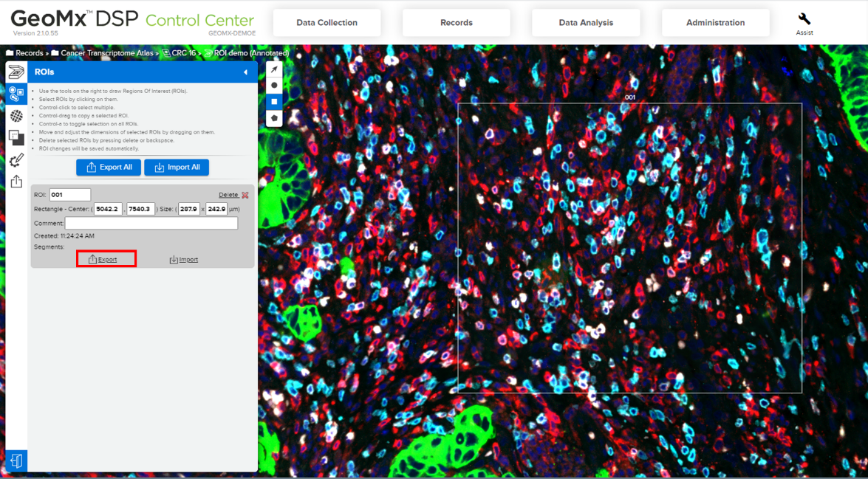

1. Now, in ImageJ, drag & drop the image file into the ImageJ workspace by directly placing it on the toolbar (shown below).

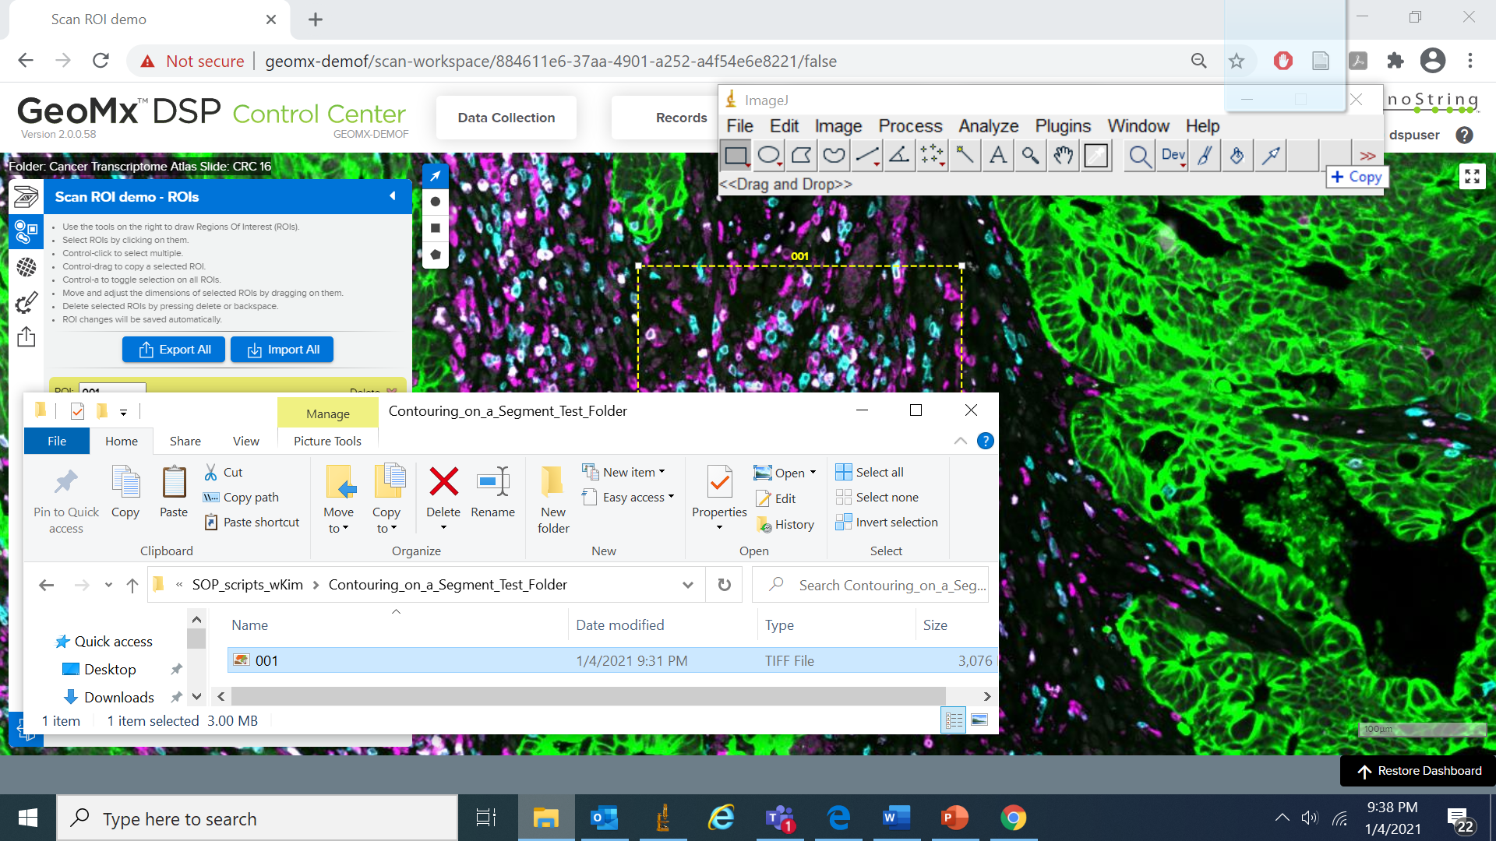

1. Next, similarly drag & drop the first ImageJ script into the ImageJ workspace.  
    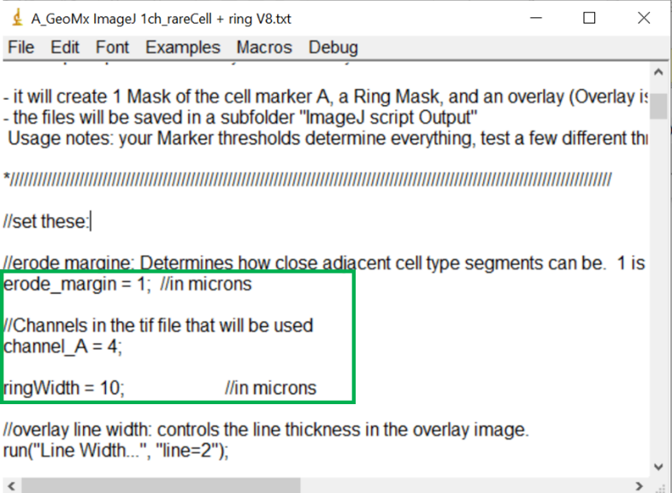
2. Enter values for the three user inputs:
   1. erode_margin = ____; determines how close adjacent cell type masks can be (ex: a value of 2 corresponds to 2 microns of erosion)
   2. channel_A = ____; determines the fluorescent channel to be used; (e.g. a value of 1: FITC Channel; 2: Cy3 Channel; 3: Texas Red Channel; 4: Cy5 Channel)
   3. ringWidth = ____; determines the ring dimensions (ex: a value of 10 corresponds to a 10 micron ring width)
3. In the script window (shown below), select **Macros >> Run Macro**

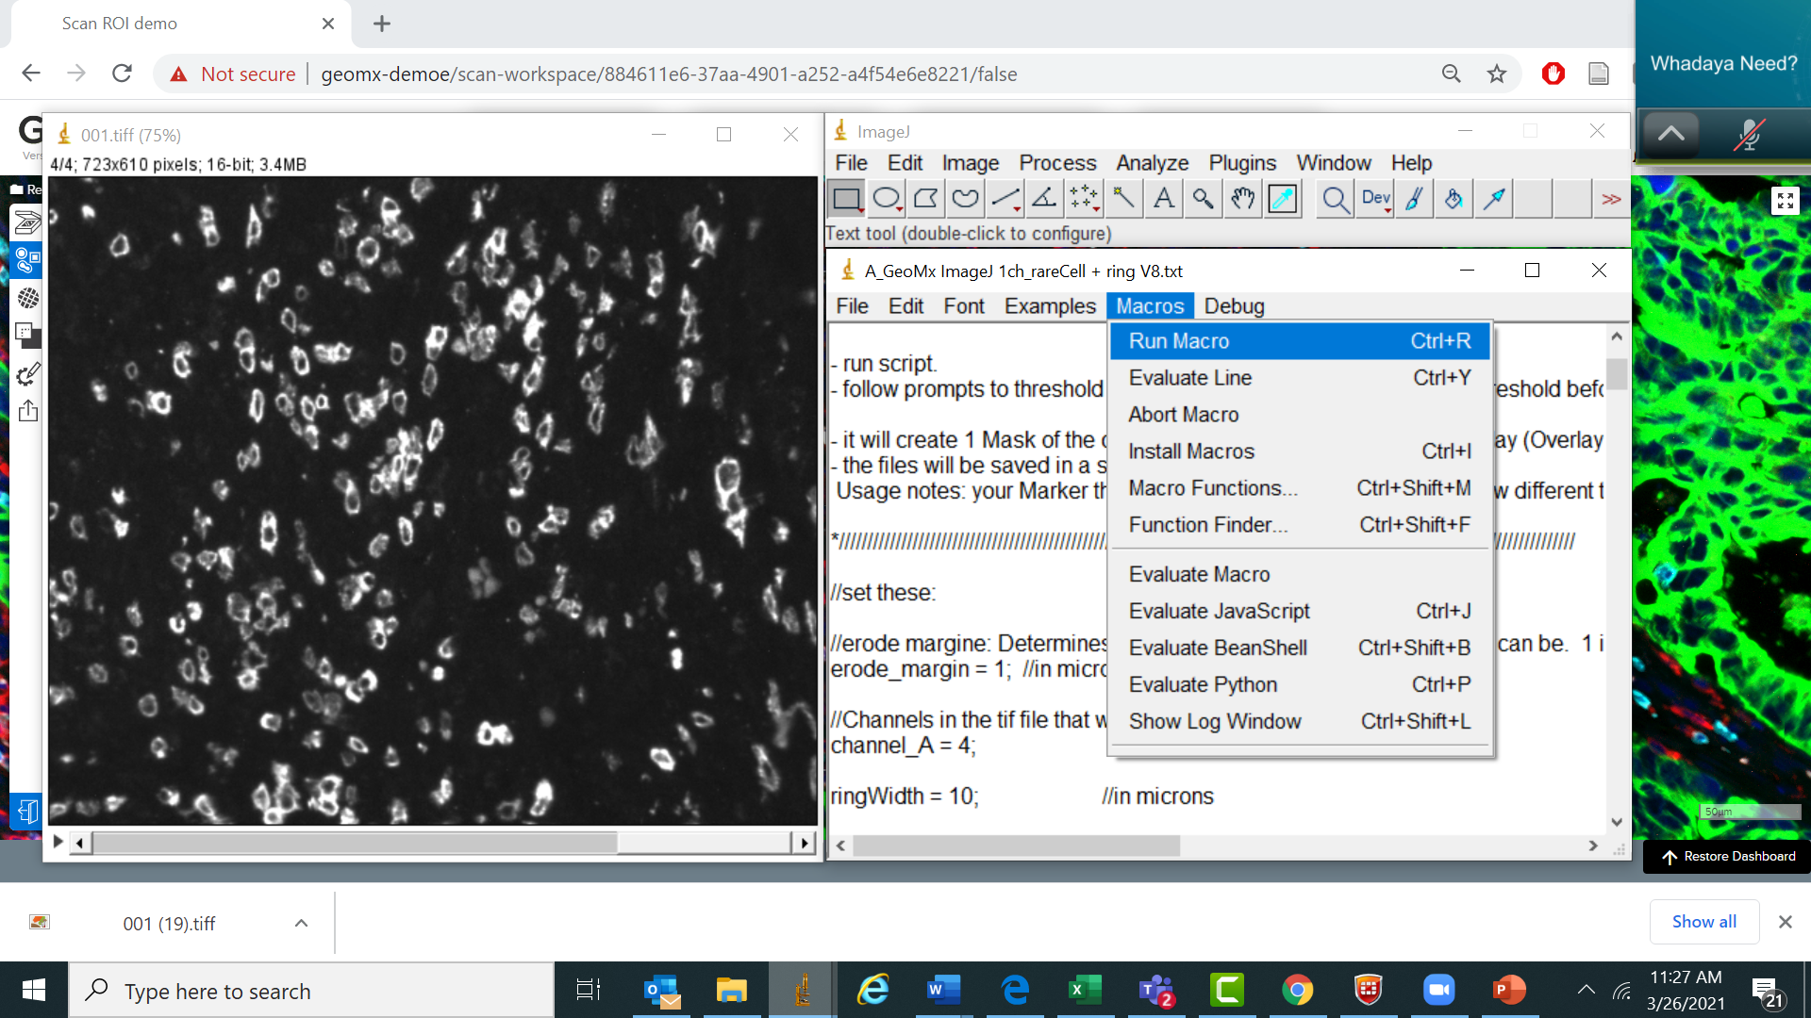

1. Three pop-ups will appear (shown below): i) your tunable image mask, ii) your thresholding slider window, and iii) the script instructions:  
   1. Use the threshold slider (red box) or the leftmost dropdown menu to select a thresholding preference; an algorithm selection from the dropdown ultimately just selects a threshold value).
      * the Li or Default algorithms are commonly used
   2. After thresholding, click **Apply**
   3. Lastly, click **OK**

Numerous windows will appear as the script runs; please ensure not to resize, change, or adjust any windows and directly proceed to Step 10.

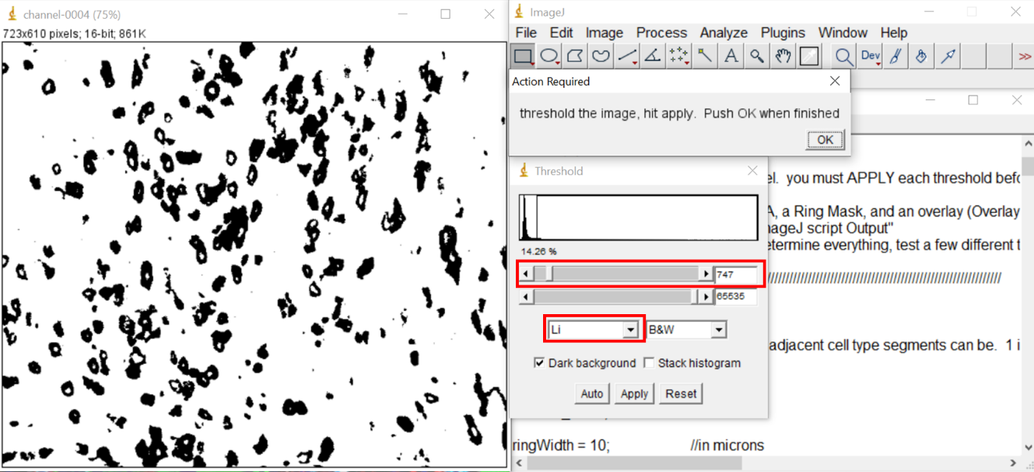

1. Masks are directly saved in the ROI image file location
2. Return to the GeoMx**®** DSP interface. Click "Import segment masks" under the ROI.
3. Import masks by navigating to the individual mask files, highlighting all of them, and clicking Open.The masks will appear on your scan with ROI details. Please ensure that the masks are named appropriately as per the instructions in the GeoMx Control Center pop-up when selecting **Import.**

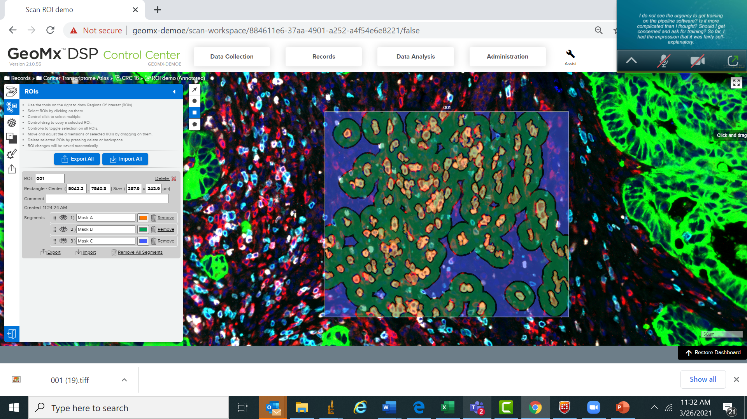

1. (Optional) To change the collection order, drag individual masks up and down the “Segment list”.
2. Proceed with other ROIs, then finalize ROIs and proceed to Collection.